**Inverted Hammer**

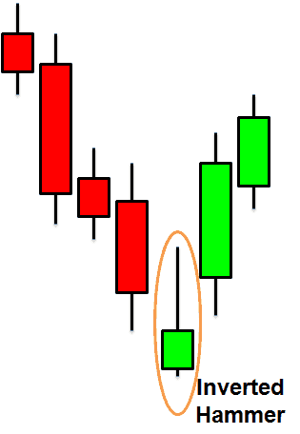

* Should be considered only when –

5 mins time frame – atleast 7 down candles

15 mins time frame – atleast 7 down candles

Daily time frame – atleast 4 down candles

* Bank Nifty – after downfall of 150 points

Nifty – downfall of 55 points

Stocks – downfall of atleast 1% of stock price

* **Remember both the above conditions must satisfy not just one.**
* Color of the hammer is not important.
* We should buy only above the inverted hammer or above the wick & stop loss should be 20 points for bank nifty & 10 points for nifty below hammer.
* Target 1 – 0.7 of the downfall . If downfall is 150 then T1 should be 100 or 80
* Target T2 – 1.0 of the downfall
* Remember – Trend of the market should be upward. If the trend of the market is downward then you might get trapped.
* **If towards the trend – quantity should be large compared to if opposite to the trend.**
* 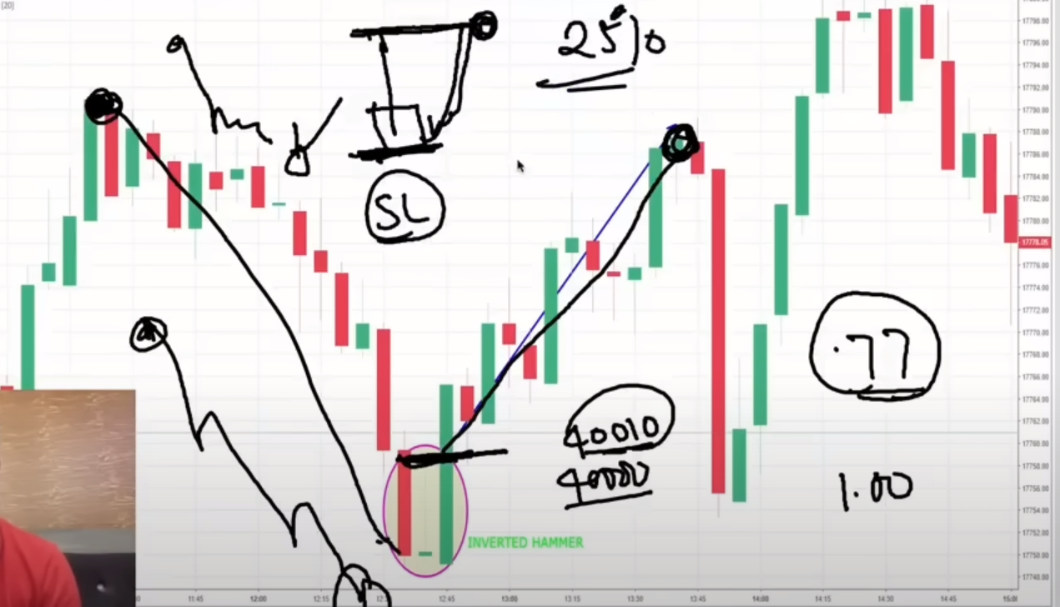

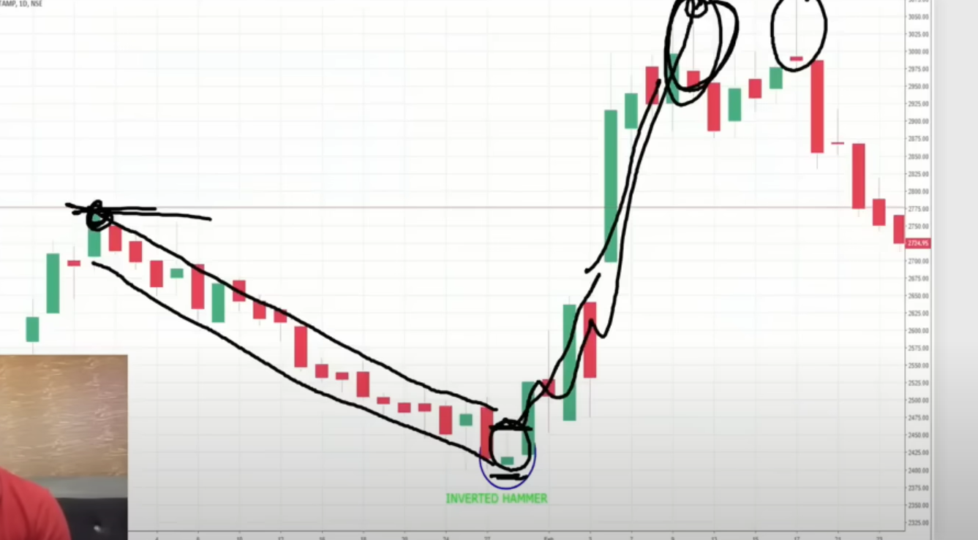

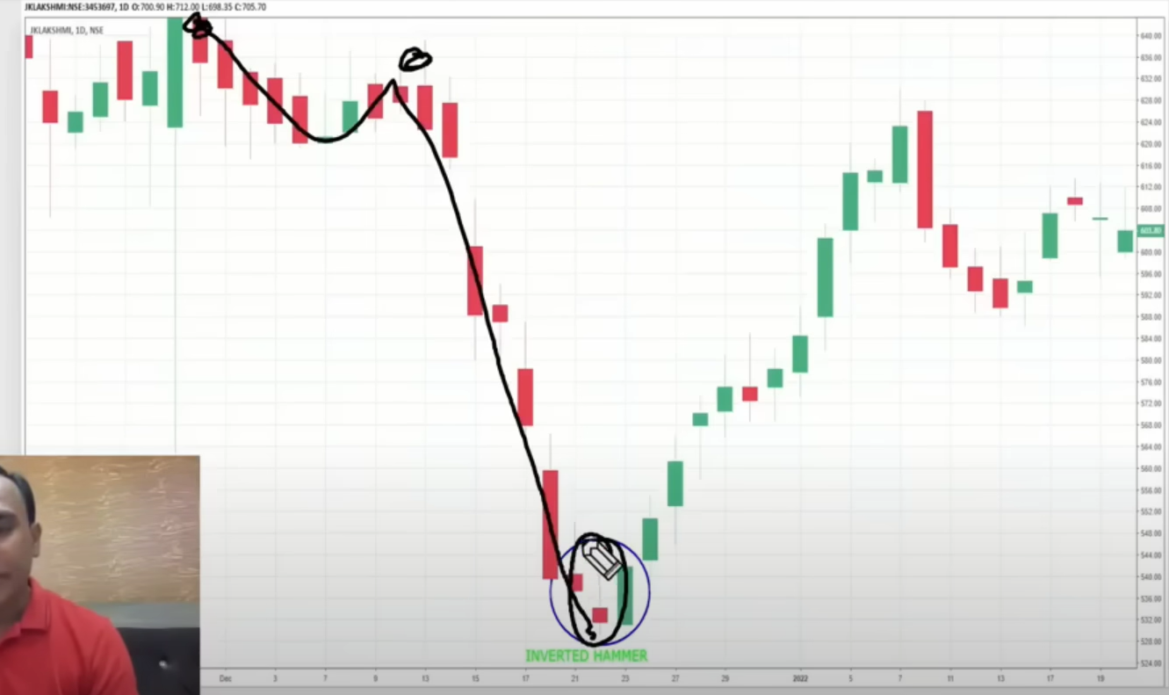

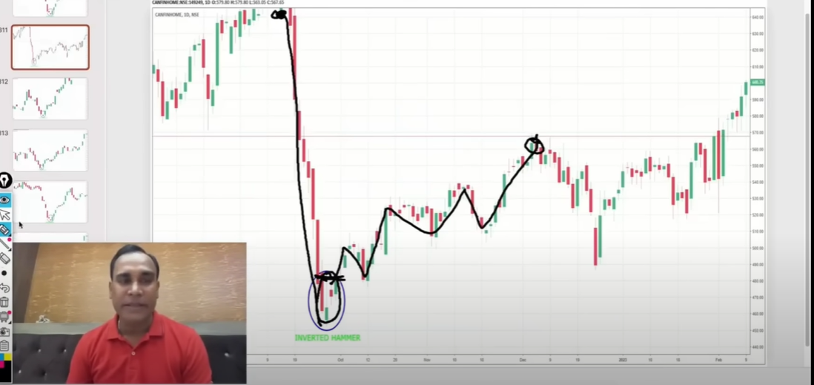

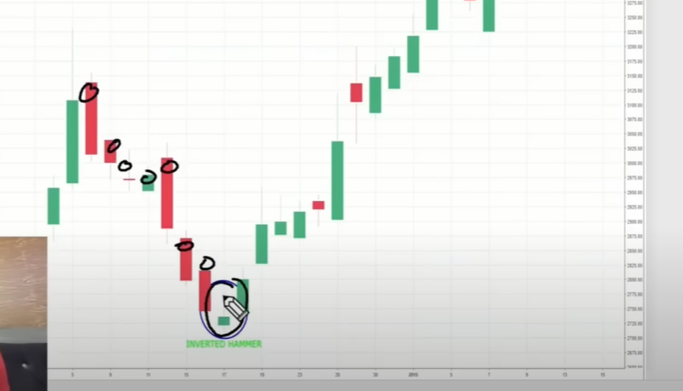

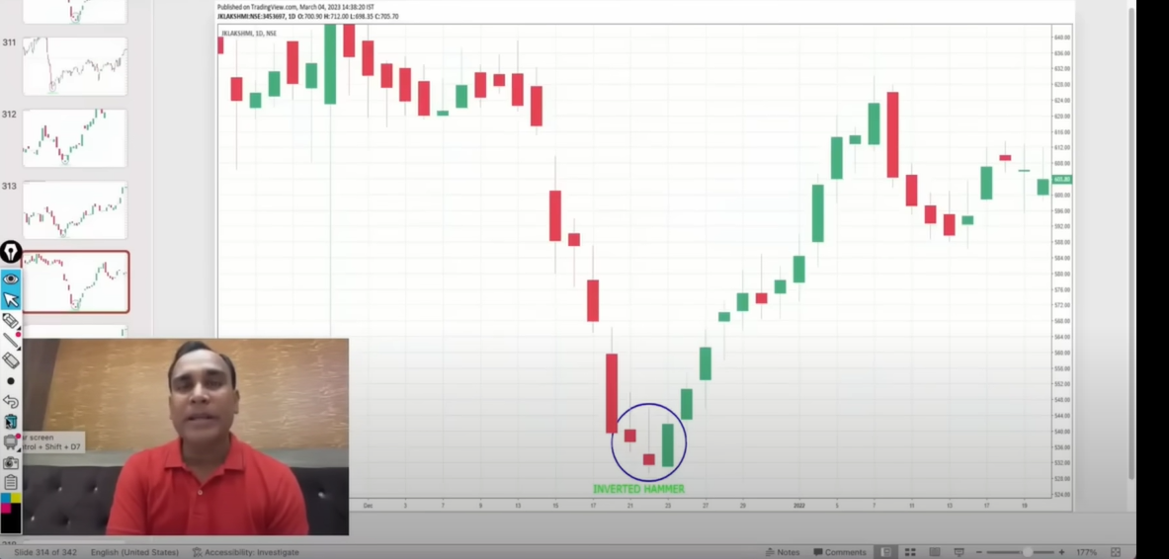

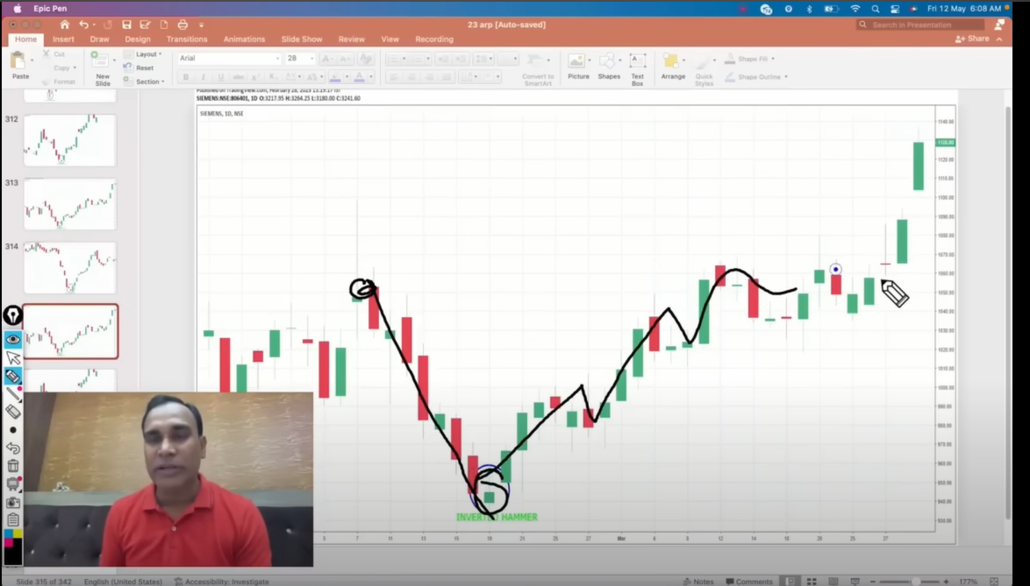

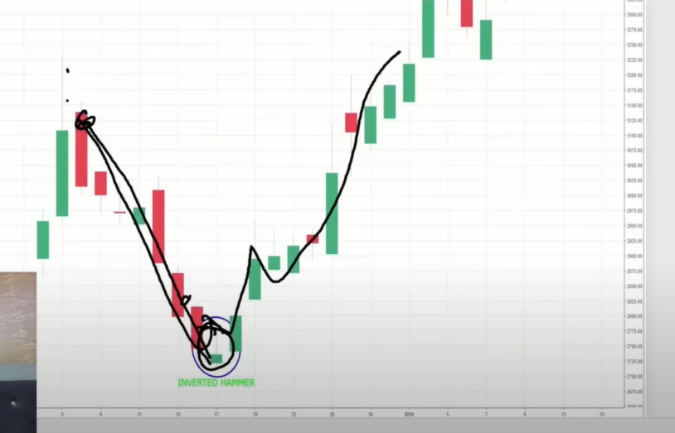

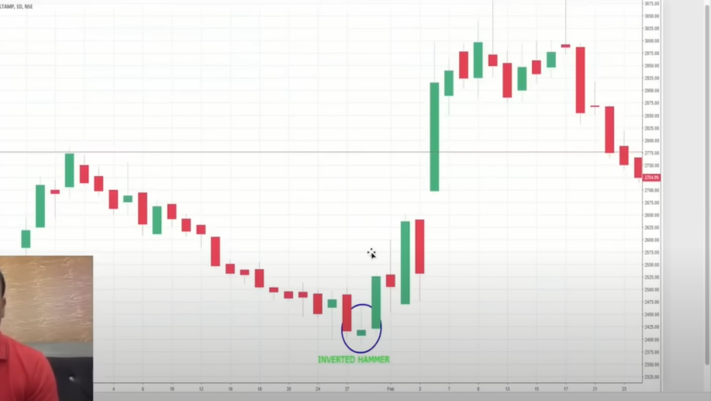

**Classical DOji**

